**What is a Gantt Chart?**

A Gantt chart is a type of bar chart that illustrates a project schedule. It's a visual tool used in project management to:

* **Show the start and finish dates of the various activities (tasks) in a project.**
* **Represent the duration of each task.**
* **Visualize the overall project timeline.**
* **Track the progress of a project.**
* **Identify dependencies between tasks.** (Though dependencies aren't explicitly shown in this particular chart, they are a common feature of Gantt charts.)

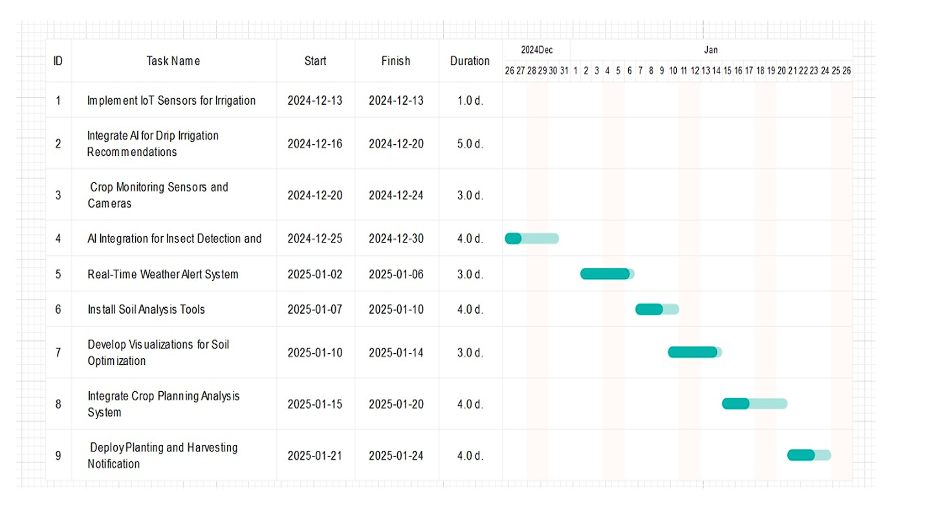

**Explanation of the Image (Gantt Chart for Smart Agriculture System Implementation):**

The image presents a Gantt chart that outlines the schedule for implementing a smart agriculture system. It breaks down the project into nine distinct tasks, each with a specific start and finish date, and a duration measured in days.

**Components of the Chart:**

1. **Tasks (Listed on the Left):**
   * The leftmost column lists the tasks involved in the project. Each task is numbered (ID) and has a descriptive name.
   * Examples: "Implement IoT Sensors for Irrigation," "Integrate AI for Drip Irrigation Recommendations," "Real-Time Weather Alert System."
2. **Timeline (Across the Top):**
   * The top of the chart shows a timeline spanning from late December 2024 to late January 2025.
   * The timeline is divided into days, with specific dates marked.
   * The months of December 2024 and January 2025 are clearly indicated.
3. **Task Dates (Start and Finish):**
   * Columns labeled "Start" and "Finish" indicate the scheduled start and end dates for each task.
   * Dates are presented in "YYYY-MM-DD" format.
4. **Task Duration:**
   * The "Duration" column shows the length of each task in days (e.g., "1.0 d," "5.0 d").
5. **Graphical Representation (Horizontal Bars):**
   * Each task is represented by a horizontal bar extending across the timeline.
   * The bar's position along the timeline corresponds to the task's start and finish dates.
   * The length of the bar represents the task's duration.
   * The bars are a teal/blue-green color, making them visually distinct.

**Interpretation of the Project Schedule:**

* The project begins with the "Implement IoT Sensors for Irrigation" task on December 13, 2024, which is completed in one day.
* Subsequent tasks follow in a generally sequential order, with some overlap. For instance, the "Integrate AI for Drip Irrigation Recommendations" task starts while the first task is complete.
* The project progresses through various stages, including sensor installation, AI integration, weather system setup, soil analysis, and crop planning.
* The project concludes with the "Deploy Planting and Harvesting Notification" task, finishing on January 24, 2025.
* The chart gives a great high level view of the order of operations, and the time that each operation should take.

**Key Benefits of Using a Gantt Chart (in this context):**

* **Project Planning:** It provides a clear visual representation of the project schedule, making it easier to plan and manage tasks.
* **Progress Tracking:** It allows project managers to track the progress of each task and the overall project.
* **Resource Allocation:** It helps in allocating resources effectively by showing the timing of tasks.
* **Communication:** It facilitates communication among team members and stakeholders by providing a shared understanding of the project schedule